Activation Report
ASAP 7.0.2 – WASS1133, JAMU66
ASAP-ORIGIN

August 16th, 2018

Contents

1 Activation Orders: JAMU66 Originated by CIS 3
1.1 JAMU66 Service Orders 3
1.2 Activation Orders Origin Distribution 4
2 Activation Orders: WASS1133 Originated by CIS 5
2.1 WASS1133 Service Orders 5
2.2 Activation Orders Origin Distribution 6

Activation Orders: JAMU66 Originated by CIS

JAMU66 Service Orders

ORIGINATING CIS | TOTAL | PERCENTAGE | COMPLETE | FAILED | TIMEOUT
CIS_JAMAICA | 36933 | 62.76% | 34763 | 1852 | 318
CIS_CAYMAN | 1386 | 2.36% | 1252 | 134 | 0
CIS_ANTIGUA | 1295 | 2.20% | 1238 | 57 | 0
CIS_ANGUILLA | 244 | 0.41% | 235 | 9 | 0
CIS_BARBADOS | 8145 | 13.84% | 7810 | 335 | 0
CIS_BVI | 2913 | 4.95% | 2907 | 6 | 0
CIS_DOMINICA | 949 | 1.61% | 932 | 17 | 0
CIS_GRENADA | 717 | 1.22% | 712 | 5 | 0
CIS_MNI | 115 | 0.20% | 101 | 14 | 0
CIS_SANTA_LUCIA | 1810 | 3.08% | 1802 | 8 | 0
CIS_ST_KITTS | 785 | 1.33% | 776 | 9 | 0
CIS_SN_VINCENT | 1504 | 2.56% | 1501 | 3 | 0
CIS_TKI | 1729 | 2.94% | 1267 | 462 | 0
OCA | 284 | 0.48% | 249 | 35 | 0
INTEGSSOFT | 0 | 0.00% | 0 | 0 | 0
CIS_172_21_64_99 | 43 | 0.07% | 25 | 18 | 0
ASAP TEST | 0 | 0.00% | 0 | 0 | 0
 | 58852 |  | 55570 | 2964 | 318

Activation Orders Origin Distribution

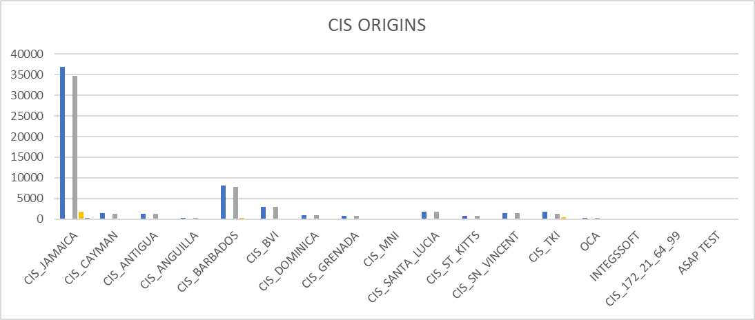

Activation Orders: WASS1133 Originated by CIS

WASS1133 Service Orders

ORIGINATING CIS | TOTAL | PERCENTAGE | COMPLETE | FAILED | TIMEOUT
CIS_JAMAICA | 15890 | 79.05% | 9776 | 4760 | 1354
CIS_CAYMAN | 0 | 0.00% | 0 | 0 | 0
CIS_ANTIGUA | 18 | 0.09% | 2 | 16 | 0
CIS_ANGUILLA | 156 | 0.78% | 109 | 47 | 0
CIS_BARBADOS | 0 | 0.00% | 0 | 0 | 0
CIS_BVI | 1487 | 7.40% | 1262 | 225 | 0
CIS_DOMINICA | 258 | 1.28% | 190 | 66 | 2
CIS_GRENADA | 186 | 0.93% | 174 | 12 | 0
CIS_MNI | 84 | 0.42% | 72 | 12 | 0
CIS_SANTA_LUCIA | 900 | 4.48% | 854 | 19 | 27
CIS_ST_KITTS | 591 | 2.94% | 528 | 63 | 0
CIS_SN_VINCENT | 288 | 1.43% | 267 | 21 | 0
CIS_TKI | 233 | 1.16% | 72 | 161 | 0
OCA | 8 | 0.04% | 5 | 3 | 0
INTEGSSOFT | 0 | 0.00% | 0 | 0 | 0
CIS_172_21_64_99 | 1 | 0.00% | 1 | 0 | 0
ASAP TEST | 0 | 0.00% | 0 | 0 | 0
 | 20100 |  | 13312 | 5405 | 1383

Activation Orders Origin Distribution

